**Iteration 0 Report**

**Team Roles**

Scrum Master: Chun-Jung Chien

Project Owner: Shao-En Chen

Team Members: Yi-Min Chou, Jeff Chang, Chu-Ya Yang, Jia-Hung Wu

**Customer Meeting**

Date: 10/5

Time: 9:00 - 10:00

Place: HRBB 516

**Summary**

(Write a two-paragraph (max) summary of the main customer need and how the application meets it, including who the stakeholders are.)

People with disability or mobility disadvantages may need to get a ride in school, so the customer wants to bring transportation on campus. Users can send request for a ride to our system, and by some algorithms we arrange an available driver and vehicle to pick her/him up. We also provide an access to the system for administrators and drivers, to check the status of other admins, drivers, vehicles and user requests, and see where the drivers and passengers are for safety reasons.

The stakeholders include administrators and staff in the vehicle center, drivers, users (TAMU students and staff).

**User Story Examples**

(All of them are on Pivotal Tracker, so here we only list a few)

--- vehicles

As an administrator,

I would like to add vehicles to the database,

so that I could know about the vehicles we have.

As an administrator,

I would like to edit vehicles’ information,

so that I could keep their information updated.

As an administrator,

I would like to delete vehicles from the database,

so that I could remove any vehicle no longer in use.

--- map

As an administrator,

I would like to see the drivers’ and passengers’ position on the map,

so that I could know where they are.

--- log in

As an administrator,

I would like to log in to the management system,

so that I could use the system.

As an administrator,

I would like to sign up for the management system,

so that I could use the system.

As an administrator,

I would like to reset the password,

so that I could use the system even if I forget the password.

**User Interface**

* Table List of administrators, drivers, and vehicles on a browser
* Create new administrators, drivers, and vehicles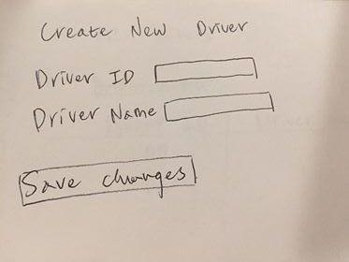
* Edit administrators, drivers, and vehicles information

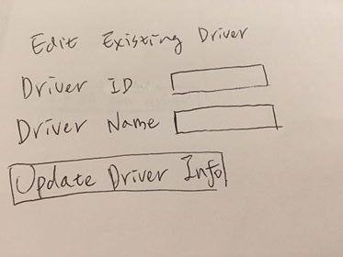

**Pivotal Tracker**

<https://www.pivotaltracker.com/n/projects/2205674>

**Video**

We did not record the video while the meeting, but we had text record for it. Will do it in the next meeting.

[https://docs.google.com/document/d/1nFU7NyqJ8AJj9GuZ7av5DgisRTcMJVHLHq_TG6-Nmo0/](https://docs.google.com/document/d/1nFU7NyqJ8AJj9GuZ7av5DgisRTcMJVHLHq_TG6-Nmo0/edit)

**Github Repo**

<https://github.com/ShaoEnChen/TAMUber>